Chapter 5, Solution 63.

The two op amps are summers. Let v₁ be the output of the first op amp. For the first stage,

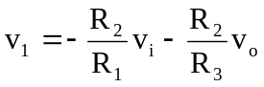 (1)

For the second stage,

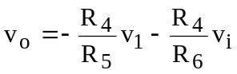 (2)

Combining (1) and (2),

